Using the @RestController Annotation

Spring 4.0 introduced @RestController, a specialized version of the controller which is a convenience annotation that does nothing more than add the @Controller and @ResponseBody annotations. By annotating the controller class with @RestController annotation, you no longer need to add @ResponseBody to all the request mapping methods. The @ResponseBody annotation is active by default.

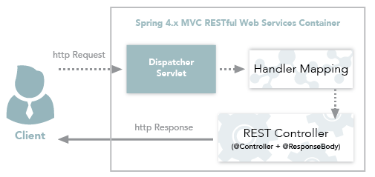

Spring4.x MVC RESTful Web Services Workflow

